Knight Inlet QC Log

Data Entry Notes & Questions

QC’ing IDs from photos / videos

# Data Entry Notes & Questions for Divers

**~~Ondine - KNI1 mobile invert datasheet~~** ~~ENTERED, but need to confirm questions below:~~

* ~~What is Tonicella marginata? - KH Solved this with me~~
* ~~If there is a ? mark, how would you like me to deal with it? (currently they are entered with a question mark)~~
  + ~~You can treat the ? as resolved. I directly edited those in the data based on our pictures -OP~~
* ~~Can you confirm the Hydroid (Quill spp) species name?~~
  + ~~You can ignore this.. It was more of a note for my pictures, I think kyle did a better job at describing the quill species -OP~~
* ~~Are you able to ID the flabellina spp from your pic?~~
  + ~~The flabellina complex has been broken up into various geniuses so it’s not even flabellina spp anymore. We’re not entirely sure but our best guess is~~ [*~~Himatina trophina~~* ~~(Bergh, 1890)~~](http://www.marinespecies.org/aphia.php?p=taxdetails&id=1047441) ~~-OP~~

**Ondine - KNI2 mobile invert datasheet**

* ~~What to do with question marks?~~
  + ~~You can treat the ? as resolved. I directly edited those in the data based on our pictures -OP~~
* ~~What is a~~ *~~Tripolax trifida~~*~~? Three rib-chiton Entered.~~ <http://www.marinespecies.org/aphia.php?p=taxdetails&id=386109#images>

**Ondine - KNI3 mobile**

* ~~“Yellow rockfish” yelloweye? Not entered. Yellowtail rockfish~~
* ~~Arrow next to straight horsemussel on datasheet? Nothing entered~~
  + ~~There were mussles in the shallows I was unable to id, I don’t think they were horselmussels though -OP~~
  + ~~AMO: Will ignore this~~

**~~Ondine - KNI5 mobile~~**

* ~~“Neptunea phoenicia”? Not entered~~
  + ~~Solved - Ang found this~~

**~~Ondine - KNI7-8 Datasheet~~**

* ~~Did you find out what the massive unknown crab (pic)D8 was? See bottom of datasheet~~
  + ~~Yes, it’s a scaled crab,~~ *~~Placetron wosnessenskii - OP~~*

**Kyle - KNI1 sessile invertebrates**

Only ENTERED things in table margins, need to confirm below:

* ~~Similiclava nivea says “singular” ----saw it on survey or just notes to self?~~
* ~~Etopleura marina says “giant pink” --- -saw it on survey or just notes to self?~~
* ~~What is Tonicella marginata?~~
* ~~“Cockle” entered as clinocardium nuttali, is that correct?~~
* ~~Did you see both “Oregonia gracilis” and Pugettia gracilis (“graceful kelp crab”)?~~
* ~~Did not enter:~~
  + ~~Yellow small sponge~~
  + ~~White sponge tall long fingers gobu bod~~
  + ~~Mopalia -> see photo~~

**Kyle - KNI2 sessile mobile**

* ~~“Burrowing anemone white banded aring”? Not entered AMO: entered as Ceriantheopsis spp.~~
* ~~“Calcareous worm -> white and flowy”? Not entered AMO: entered as serpula spp.~~
* ~~“White encrusting sponge” Not entered AMO: not entered~~
* ~~“White lamp shell”? Entered as: Laqueus californicus~~
* ~~“Purple tunicate with canals”? Not entered unable to ID, will not enter~~
* ~~“Flat branched bryo”? Not entered - unable to ID, will not enter~~
* ~~“Jelly worm?”? Entered as Myxicola infundibulum~~
* ~~“Leaf hornnotu”? Entered as:~~ *~~Ceratostoma foliatum~~*
* ~~“Giant peach tunicate”? Entered as:~~ *~~Halocynthia aurantium~~*
* ~~“Spegefly worm”? = Spaghetti worm, Terabellida~~

**Kyle - KNI3 - sessile mobile**

* ~~What do these say? Not entered yet AMO: entered~~  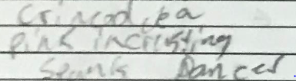
* ~~“Red polyplac”? Entered as red-veiled chiton~~
* ~~3 sponges: “yellow”, “pink”, and “white”? Not entered AMO: note entered.~~
* ~~“Leafhorn”? Not entered AMO: entered as ceratostoma foliatum~~
* ~~“Octo”? Not entered sed. Entered as: Enteroctopus dofleini~~
* ~~What do these say? Not entered 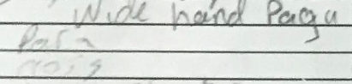~~
  + ~~ENTERED: Elassochirus tenuimanus, Parastichopus parvimensis, Crassadoma gigantea~~
* ~~“Hairy checker”? Entered as checkered hairysnail~~
* ~~“Margarites”? Entered as Baird’s margarite <-AMO removed entry. Entered as: margaritas pupillus~~
* ~~What does this say? Keyhole and oregon… limpet? Not entered 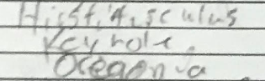~~
  + ~~Entered as:~~ *~~Pagurus hirsutiusculus,~~* ~~Diadora aspera, and Oregonia gracilis~~

**~~Kyle - KNI5 - sessile mobile~~**

* ~~Need help reading~~
* ~~Entered: line 2 as Evasterias and line 5 as dungeness crab~~
* ~~Not entered: lines 1 = AMO entered as Oregonia gracilis , 3 = AMO entered as Cyanea capillata , 4 = AMO entered as stary flounder Platichthys stellatus, 6 = AMo entered as pagurus granosimanus~~

~~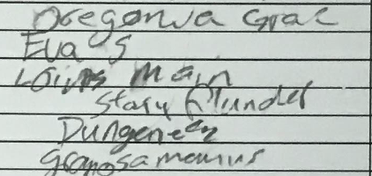~~

**Kyle - KNI8 sessile mobile**

* ~~“Red white spotted anemone”? Not entered - Entered as Urticina eques~~
* ~~“Burrowing anemone little whity” Not entered - Entered as Pachycerianthus fimbriatus~~
* ~~“Quill”? Not entered - Entered as Sebastes maliger~~

**Kyle - KNI9 - sessile datasheet**

* ~~Checking if “boot” = boot sponge. AMO entered as boot sponge. Deleted boot sponge and entered as gum boot chiton Cryptochiton stelleri~~
* ~~Under “boot” does it say agarum? AMO did not enter this yet. Entered~~
* ~~What is “alternating? hydroid”. AMO did not enter this yet. Entered as Thuiaria spp.~~
* ~~What is “Tonicella oter”. Did not enter yet Entered as Tonicella insigni~~
* ~~What is under Tonicella. Did not enter yet. Entered as pagurus granosimanus~~

**Zach - KNI1 - mobile**

* Checkmarks between two sets of columns - were the species in the left columns seen? All other checkmarks on data sheets are like ones on right (between scientific and common name). Four species on the left not entered.

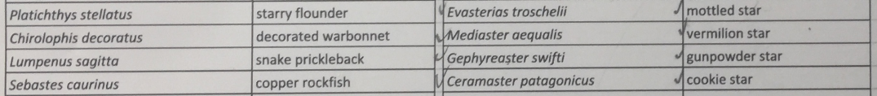

**Zach - KNI1 - sessile**

* What are the dots? In place of checks sometimes there are dots. Not entered.

**Zach - KNI2 - mobile**

* “2”s entered (presumably that’s just a count?)
* Same question as for KNI1 - what are the dots?

**Zach - KNI6 - sessile**

* Dots? Not entered
* Numbers assumed are counts, entered
* Clarify species in notes not yet entered (no asterisk = not entered)

**Zach - KNI4 - sessile**

* Clarify species in notes not yet entered (no asterisk = not entered)

# QC’ing and entering IDs from photos / videos

**October 19, 2020 -** Angeleen making sure Ondine’s and Zachs species ID from images are in master species list. Ondine’s photos are under “Species Photos”, and Zach has a list of species in a tab in the master spreadsheet.

a) ONDINE’S DIVES

* KNI2 completed, except
  + Added algae: membranoptera sp/Branchioglossum bipinnatifidum (wet). -> added as red algae, could be either of these species

- KNI3 completed

- KNI5 completed

- KNI7 completed, except:

~~- What is the fusili triton? A link will do :) === fusitriton-oregonensis~~

- KNI8 completed, except:

~~- Can’t find ‘spplumulariids’ from Henry’s ID (2 photo down). Am I reading this wrong?   
 OH, figured this out === PLUMULARIID.~~

- Are transparent tunies = *Corella willmeriana* ? or unknown?

- **Did not enter :**

- Adocia sp

- Webrella sp

- Eualus sp

- Henricia sp (other Henricia species were ID’ed)

- Brachiopod

- Tube worm

- Branched Bryozoan

- orange sponge?

- Branched bryozoan

- chiton and zanthoids

- Metridium?

-tunicate

-tunicate and hydroids

- transparent tunies

-KNI1

~~- Solaster (newly described?) ==== S. papillus~~

b) ZACH’s DIVES

* Entered, but confirming Hydroid and sponges
* 2020-10-23: Zach added Psolus to species list from KNI4; wasn’t recorded, but apparent in video